

**UNIVERSIDAD TECNOLÓGICA DE**

**SAN LUIS RIO COLORADO**

**PRACTICA 6**

**MTRO. RICARDO ALEJANDRO SOTO MORALES**

**AUTOR: VICTOR MANUEL GALVAN COVARRUBIAS**

San Luis Rio Colorado, Sonora Julio, 2020

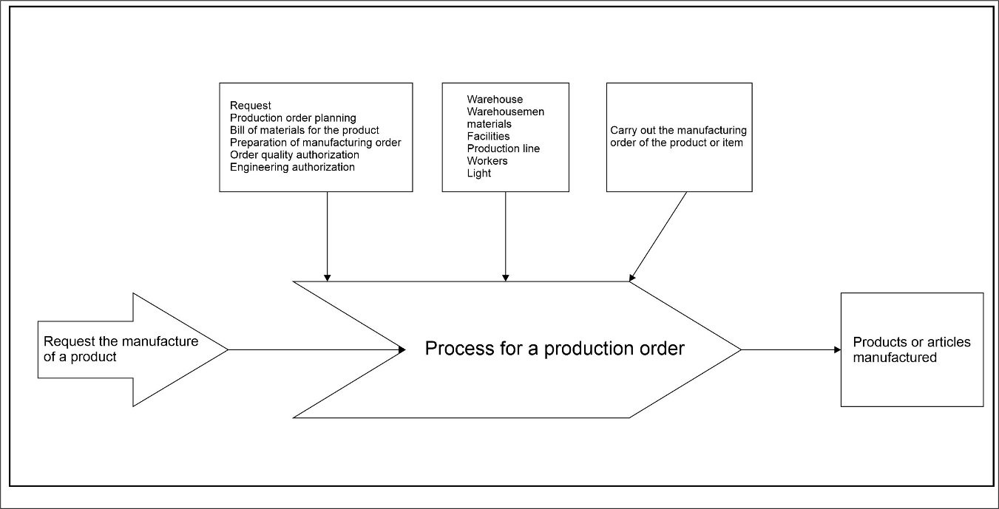

Illustration 1: Process diagram of a production order.

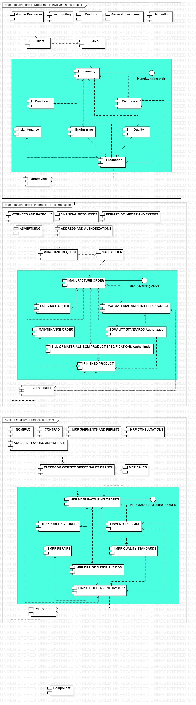

Illustration 2: Component diagram Areas involved in the process.



Illustration 3: Component diagram Process information / documentation.



Illustration 4: Component diagram Systems used in the process.

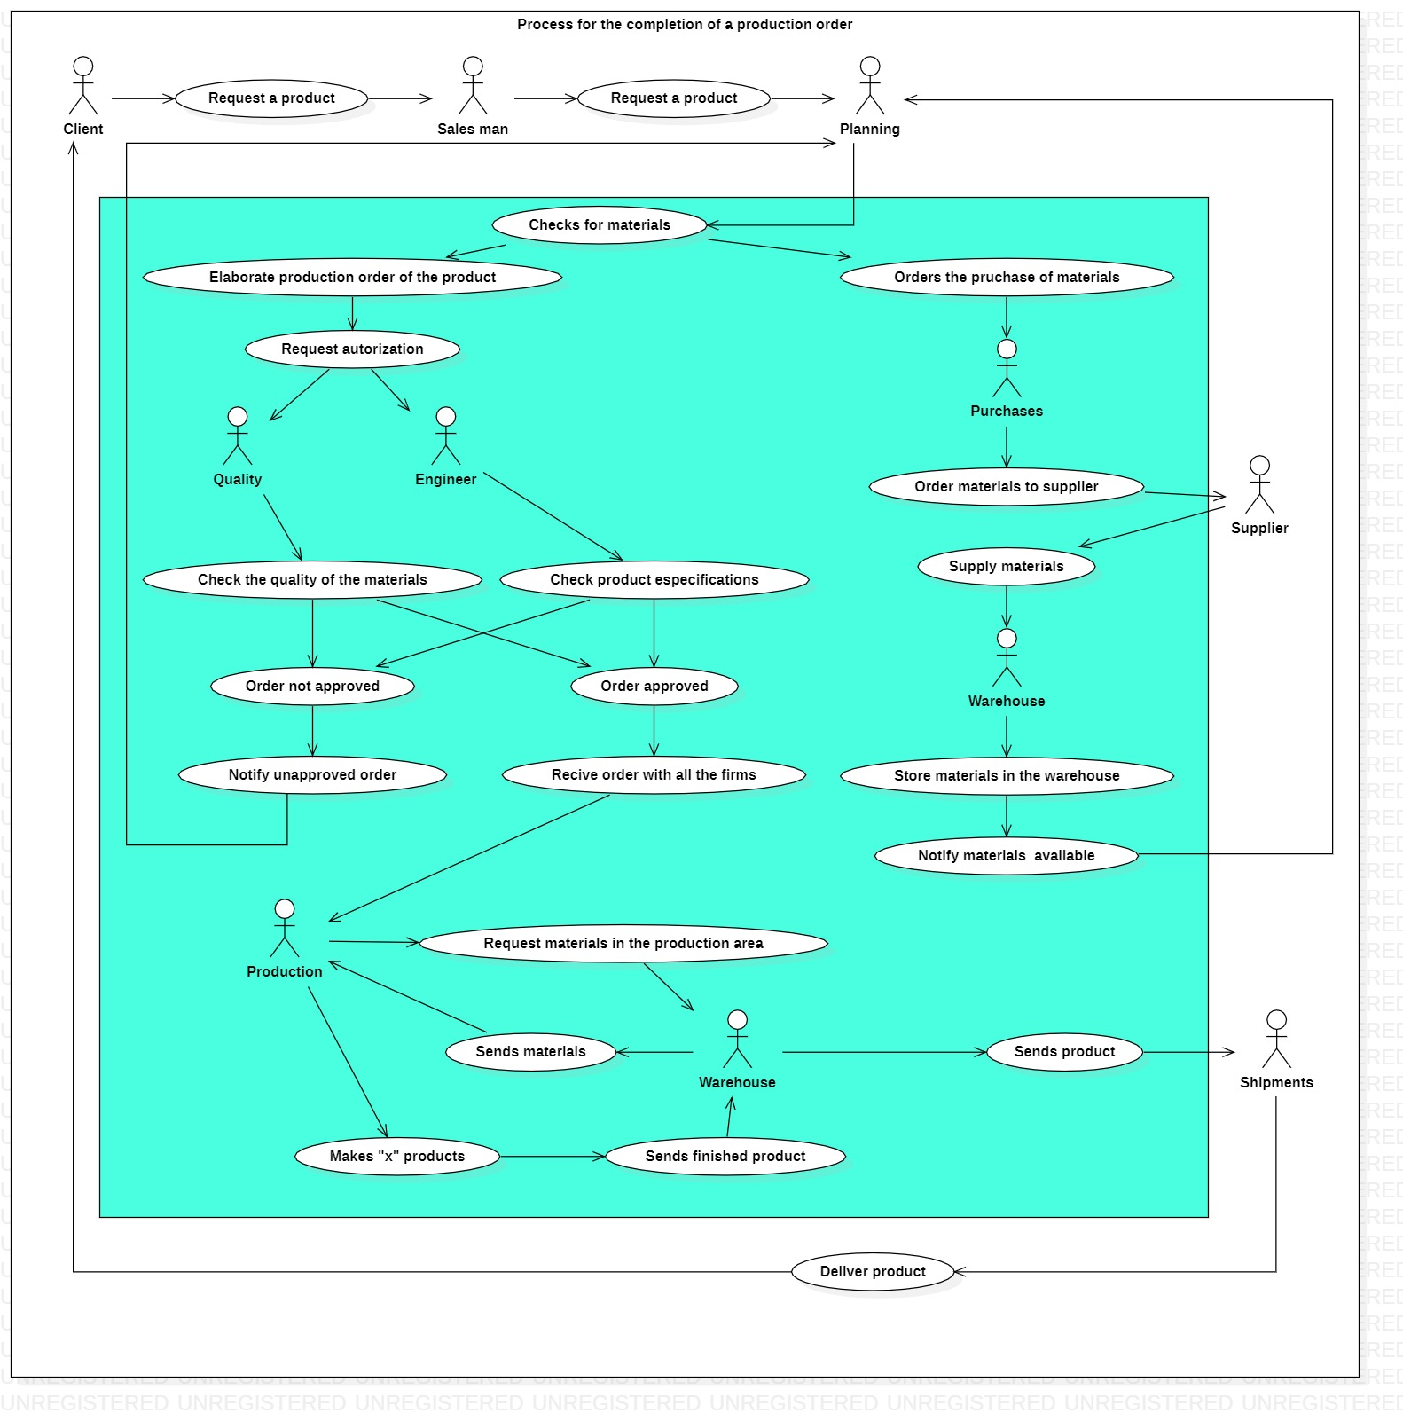

Illustration 5: MRP Use Case Diagram.